Dear Parents and Guardians,

We’re excited to tell you about an upcoming event. On [INSERT DATE], Children’s & Young Adult author/illustrator Christine Almstrom will visit to speak to students in [INSERT GRADES]. Mrs. Almstrom writes and illustrates picture books for preschool through grade 3 and fiction books for children and young adults. She is an enthusiastic speaker who excites students about reading with personal stories and shares tips she’s developed during her experience as a writer and illustrator.

If you would like your child to have a book signed by the author or to order books for gifts, please complete and return this form with payment to your child’s teacher. Mrs. Almstrom will sign and personalize each book. Thank you.
Sincerely,
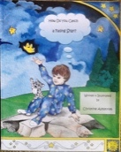
[INSERT YOUR NAME & TITLE]
How Do You Catch a Falling Star? – With boundless imagination, a little boy and his ‘kitty companion’ try to catch a star of their own throughout an adventurous day. [Humor, rhyme, counting, and analytical thinking. Pre-K/early reader; ages 3-8]

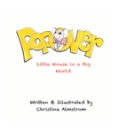
Popover: Little Mouse in a Big World – Popover is tired of being small. When he decides to be big one day, he realizes sometimes being big is harder than it looks.
[Humor, intuitive reasoning. Pre-K/early reader; ages 3-8]

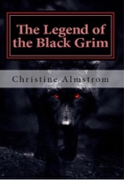
The Legend of the Black Grim – When Granger Ironwood moves to secluded Grimwold before his 13th birthday, he thinks starting over in a new town is the worst part but he couldn’t be more wrong. Are the stories of the demon dog that returns every thirteen years true? He’s about to find out. The thirteenth year starts now…[Legend, nature, supernatural. Middle-grade/Horror; ages 8-12]
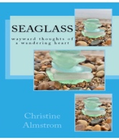
Seaglass: wayward thoughts of a wandering heart – Poetry and sketches of a restless mind and sensitive heart. Insights into the strange and surreal world we live in and the hidden beauty of ordinary moments. [Poetry, pencil sketches/art; ages 8-adult]
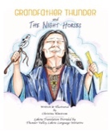
Grandfather Thunder & The Night Horses – Loosely based on the Lakota legend of the Thunder Horses, this creation story tells of the origin of thunder, lightning, and rain. When a young girl is frightened of a storm, her grandmother calms her fears with Grandfather Thunder’s story. [Bilingual English/Lakota; pre-K/early reader through 3rd grade; ages 3-10
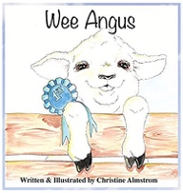
Wee Angus – A tiny, orphaned lamb finds fitting in with the rest of the flock challenging. He may look like a sheep but he doesn’t smell like a sheep. He doesn’t sound like a sheep. He doesn’t even act like a sheep. Will he ever fit in? [Humor, self-acceptance; Pre-K/early reader; ages 3-8]

✂- - - - - - - - - - - - - - - - - - - - - - - - - - - - - - - - - - - - - - - - - - - - - - - - - - - -
Book Order & Autograph Form

Child’s Name (please print)_______________________________________
Child’s Teacher ________________________________________________
HOW DO YOU CATCH A FALLING STAR?
______ books @ $12.99 each = $________

POPOVER: LITTLE MOUSE IN A BIG WORLD
______ books @ $9.99 each = $________

THE LEGEND OF THE BLACK GRIM
______ books @ $9.99 each = $________

SEAGLASS: WAYWARD THOUGHTS OF A WANDERING HEART
______ books @ $13.99 each = $________

GRANDFATHER THUNDER & THE NIGHT HORSES
______ books @ $16.99 each = $________

WEE ANGUS
______ books @ $14.99 each = $________

Total = $________

Please make check payable to [INSERT YOUR SCHOOL NAME] and return to your child’s teacher by [INSERT DATE].

